VCO step-response test (Crystek VCO, Vt driven by Syscomp CGR-201)
Measured 10 October 2026. Square wave at 50 kHz on Vt, low level 0.5 V, high level stepped from 0.75 V to 3.0 V. Drive on scope CH1, VCO RF output on scope CH2 (Siglent SDS1104X-E, 500 MSa/s). Vcc 11.5 V. 1112 rising edges averaged per level.

Summary
- The VCO's frequency rises in 100-176 ns (10-90 %) for every step, but this is limited by the Syscomp's own edge (about 145 ns), not by the VCO.
- Mapping the measured drive waveform through the tuning curve reproduces the frequency trace with a lag of 0-12 ns, below the roughly 20 ns resolution of this setup.
- The rise time varies with voltage because the tuning curve is not a straight line: it is steepest around 1.5-2.25 V.
- The settled frequency differs from the earlier spectrum-analyzer table by up to about 10 MHz (765 MHz versus 751 MHz at 0.5 V). The VCO was driving an unterminated 1 Mohm scope input here, which may explain it; this was not tested.
- The scope cannot sample 765-875 MHz directly. The signal was recorded as an alias (235-125 MHz) and unfolded; a static check at 1 GSa/s confirmed the unfolding.

Rise time vs input voltage
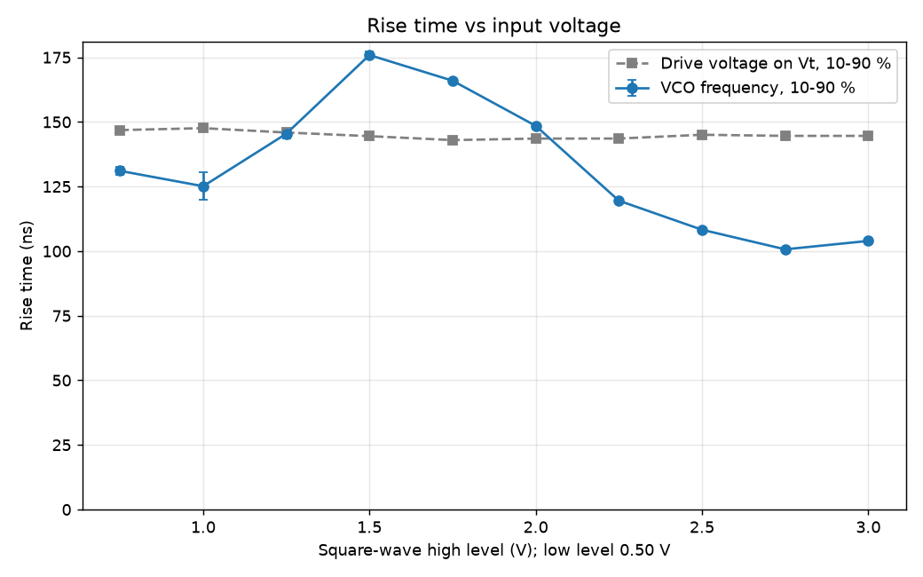
10-90 % rise time of the VCO frequency and of the drive voltage, versus the square wave's high level. Error bars are the scatter between four subsets of the captures.

Frequency vs time
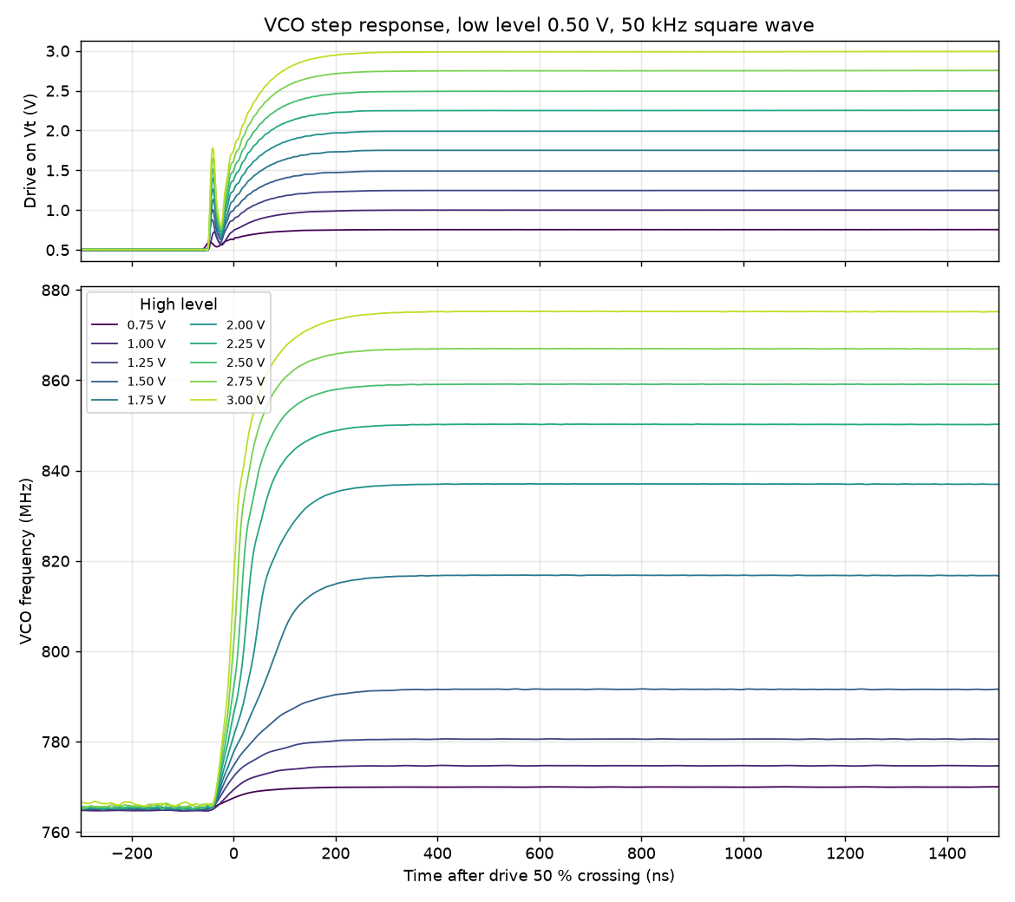
Top: averaged drive voltage on Vt. Bottom: averaged VCO frequency through the step, for each high level. Time zero is the drive's 50 % crossing.

Settled frequency vs tuning voltage
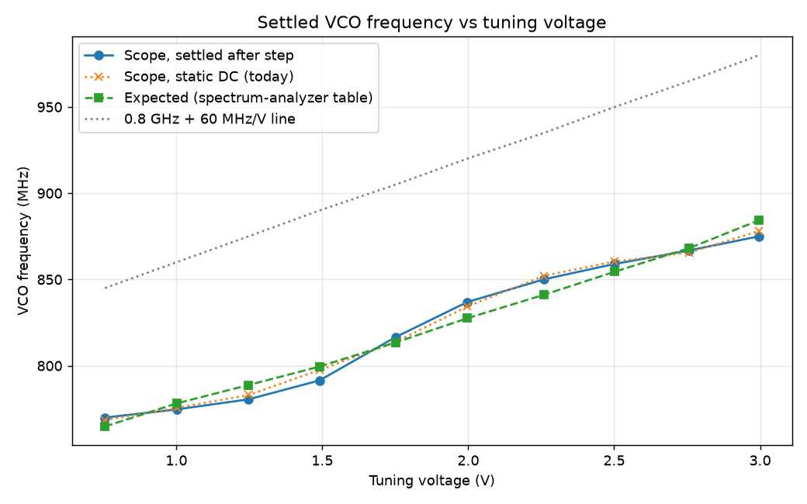
Settled frequency after each step, the static DC tuning curve measured the same day, the expected value from the spectrum-analyzer table in 'VCO tests.xlsx', and the 0.8 GHz + 60 MHz/V line.

Data table
Square wave (kHz) | High level set (V) | High level measured (V) | Expected freq. (MHz) | Measured freq. (MHz) | Freq. rise 10-90 % (ns) | Settle to 5 % (ns) | Drive rise 10-90 % (ns)
50 | 0.75 | 0.755 | 764.8 | 769.9 | 131 +/- 2 | 130 | 147
50 | 1.00 | 1.001 | 778.1 | 774.7 | 125 +/- 5 | 142 | 148
50 | 1.25 | 1.248 | 788.8 | 780.5 | 145 +/- 2 | 148 | 146
50 | 1.50 | 1.491 | 799.5 | 791.5 | 176 +/- 1 | 190 | 145
50 | 1.75 | 1.752 | 813.5 | 816.6 | 166 +/- 1 | 178 | 143
50 | 2.00 | 1.996 | 827.5 | 836.9 | 149 +/- 0 | 162 | 144
50 | 2.25 | 2.260 | 841.2 | 850.1 | 120 +/- 0 | 134 | 144
50 | 2.50 | 2.502 | 854.5 | 859.0 | 108 +/- 0 | 122 | 145
50 | 2.75 | 2.758 | 868.2 | 866.9 | 101 +/- 0 | 114 | 145
50 | 3.00 | 2.997 | 884.4 | 875.0 | 104 +/- 0 | 124 | 145
Low level: set 0.50 V, measured 0.501 V, 765.3 MHz (expected 751.4 MHz). Raw captures and scripts: clinic/vco_rise_time/data/20261010_155415/.

